**A Project Report on**

**PLACEMENTOR**

***Submitted in the partial fulfilment of the requirements for the***

***Major Project of***

**BACHELOR OF TECHNOLOGY**

In

**INFORMATION TECHNOLOGY**

Submitted by

ANURAG POLA 18071A1264

ARPAN JAIN 18071A1266



**Under the esteemed guidance of**

**PROJECT GUIDE**

I. Pavan Kumar

Assistant Professor,

Dept. of Information Technology,

VNRVJIET

**DEPARTMENT OF INFORMATION TECHNOLOGY**

**VNR Vignana Jyothi Institute of Engineering & Technology**

(Autonomous Institute, Accredited by NAAC with ‘A++’ grade and NBA)

Bachupally, Nizampet (S.O.) Hyderabad- 500 090,

February 2022

Table of Contents

|  |  |
| --- | --- |
| **Abstract………………………………………………………………………**  **List Of Figures……………………………………………………………….**  **Chapter-1 : Introduction**  **1.1 Problem Statement……………………………………………....**  **1.2 Existing Methods…...…………………………………………....**  **Chapter-2 : Methodology**  **2.1 Proposed System…...…………………………………………….**  **2.2 Requirements…………………………………………………….**  **2.3 Workflow Diagram...…………………………………………….**  **2.4 Designs……………………………………………………………**  **Chapter-3 : Conclusion……………………………………………………..**  **Chapter-4 : Future Scope………………………………………………….**  **Chapter-5 : References……………………………………………………...** | **(i)**  **(ii)**  **1**  **1**  **5**  **7**  **11**  **12**  **17**  **18**  **20** |

**ABSTRACT**

Every college desire to see their students settled in their career, the first phase of which is them getting a good placement. Placements also reflect the standards of the college. Hence placements are a key element to both college and students. But today, many colleges are using some sort of messaging platform such as WhatsApp, Telegram to establish communication between students and Training & Placement Cell on placement-related activities. This also consists of a lot of manual work and is tedious. Negligence on even a small thing from either party would result in great loss. A better solution is needed to address the issues faced by both college and students in the context of placements. Hence, we are building a platform that enables students to seamlessly access placement-related information while on the other side Training & Placement cell can get an easy way to both monitor students and provide information about the same.

**LIST OF FIGURES**

|  |  |  |  |
| --- | --- | --- | --- |
| **Sl. No.** | **Figure No.** | **Figure Name** | **Page No.** |
| 1. | 2.3.1 | Workflow Diagram | 11 |
| 2. | 2.4.1 | On-boarding Screens | 12 |
| 3. | 2.4.2 | Login, Companies Tab, Off-Campus Opportunity Screen, Newsfeed and Resources Tabs | 13 |
| 4. | 2.4.3 | On-Campus Opportunities Screen | 14 |
| 5. | 2.4.4 | Profile and its constituent screens | 15 |
| 6. | 2.4.5 | Off-Campus Opportunity and Raise Ticket Forms | 16 |

**CHAPTER - 1**

**INTRODUCTION**

**1.1 PROBLEM DEFINITION**

As placements play a major role for both college and students, a dedicated platform is required to solve issues like

* No proper communication between students and the T&P department
* Partial/Incorrect information regarding placement drives
* Missing deadlines of opportunities, both on-campus and off-campus
* Improper tracking of students’ progress from T&P and students themselves
* No proper guidance to prepare for placements
* Inefficient feedback system

The problem here lies in the non-availability of a dedicated online single window channel between the Training and Placement team and the students which could solve the above-mentioned issues.

Hence, building a platform that enables students to seamlessly access placement-related information while on the other side Training & Placement cell can be an easy way to both monitor students and provide information about the same.

**1.2 EXISTING SOLUTIONS**

**1.2.1 WhatsApp Groups**

In our college, the T&P cell uses WhatsApp as a medium for communication with students about placements. Each branch and batch are asked to join in their respective WhatsApp groups and every information related to any new drive is posted as a message in the group. Sometimes polls like those “who have registered for an exam” or “who got qualified in a placement round” are also posted for which the students reply with a hand raise emoji to confirm their completion or update a list with their roll number and name. Also, when a new company arrives its basic information along with the tech stack required is posted in the group, sometimes previously placed student contact details are provided which would help current students to clear their doubts when needed. Also, if there are any queries related to the drive the students post the doubt in the group and the respective placement coordinator resolves it.

These days many companies started hiring through country-wide hackathons and exams which are considered to be off-campus. Many students do participate in outside college drives and internships which then need to be communicated to the T&P Department and require updation in records regularly.

Advantages:

* The communication is easily done
* There is no need to install any new application (as WhatsApp is highly used by many people)

Disadvantages:

* A lot of manual work is intended for both faculty and students.
* There is also a high chance of the messages being spammed which might lead to loss of valuable information.
* Students might ignore the notifications of WhatsApp thinking it is not from the placement group
* The platform cannot be customized as per the required format a college needs.

The existing system is more manually done which intakes many human errors and irregularity in the maintenance of data. Communication is highly based on WhatsApp. It does not provide placement-specific information communication features and issues arise when Meta’s server fails. Till now no single proper channel is established between the TnP department and the students.

**1.2.2 Google Classrooms**

In NIT Hamirpur, the mode of communication being used is Google classroom. It is similar to the usage of WhatsApp; Google Classrooms are made for each branch’s batch and respective information is placed in respective classrooms. The Google Meet link for things like pre-placement talk is attached directly in the classroom so that students can easily access it.

Advantages:

* Communication is relatively easy
* As classroom notifications differ from WhatsApp notifications, students know that something related to placements has come up when it is from the classroom app
* No spamming can be done

Disadvantages:

* There is manual work intended here too to collect information from students
* There is no proper feedback system
* The platform cannot be customized as per the required format a college needs.

**1.2.3 Web Portals (IIT Kanpur)**

At the Indian Institute of Technology, Kanpur, a single-window platform is developed by the college where companies register onto this platform and students can directly apply from here for the placements. While this process does not require the direct intervention of the TnP department, they regulate and monitor the platform and the process continuously. Students can directly ask doubts and questions to the firm and get a direct reply. The process has been more automated and organized.

Advantages:

* Reduce workload on TnP Cell
* Provide more transparency in the process
* Students would be directly introduced to the real placement world with many more options so that they can be selected for their future.

Disadvantages:

* Companies would have a lot of workloads and need to be regularly active on the platform.
* Not all companies are digitally good and active.
* Due to hectic workloads to companies, placement to the college might get impacted.

The above model cannot be used in our college – VNR VJIET as we have many companies approaching us who are not good with the online world and prefer a direct conversation with the management (or) Placement Cell rather than with students.

**CHAPTER - 2**

**METHODOLOGY**

**2.1 PROPOSED SYSTEM**

We took insights from all the existing solutions and tried to remove some of the disadvantages in them but also retain the advantages. Hence, we are building an app and a website that would enable students and T&P to communicate with each other in a better way.

**The Mobile Application**

We are building an app that connects students to the T&P Faculty. As apps are handy and we can also use on-device storage to provide details in offline mode too.

The following are the screens and their details along with their design

1. **Login Screen**

We have induced a security check to access the app’s content. This is a useful step as it protects the college’s placement data from the outside world. This data should only be accessible to the related users only.

1. **Companies Page**

This screen lists out all the available on-campus and off-campus opportunities

Both the lists are separately shown as a horizontal and vertical scroll view and with each company listed as a tile in both the lists. When clicked on any of the tiles the respective company page is opened.

1. **On-Campus Company Page**

As the college has all the information about the companies visiting, we have a lot of information available on this page which includes

1. **About the firm:** A little information about the firm so that the students get to know the baseline of the organization.
2. **Job Description:** This contains the specific description of the role the company is offering in terms of expectations of the company from the student.
3. **Skillset required:** This section contains the stack required for the role of the company.
4. **Process:** This contains a flow chart that shows the students the steps they need to take in the process of trying to get placed in the company.
5. **Previously placed contacts:** This section provides information about alumni who got placed in the same company or role so that if they have any doubts, they could contact them with just a click.
6. **Experiences:** Some of the experiences from the previous batches are collected and are put here to let the students know a pinch of how the process and company are going to be.
7. **FAQs:** The most frequently asked questions about the firm by the students are answered and are put in this section.

Also, a drive link with all the resources related to the organization in the possession of colleges such as mock tests, etc., and an add-to calendar option would be provided so that this page could be a one-stop-shop for all the requirements of students.

1. **Newsfeed Page**

This screen is used to provide updates from TnP Cell to students. This can be used to decrease the dependency on online conversation applications like WhatsApp and Telegram. It also provides a feature to conduct polls.

1. **Resources Page**

This screen provides resources as sample resumes, video resumes, aptitude lectures, etc. This would be helpful for students to refer, watch and develop their knowledge and portfolios anytime anywhere.

1. **Profile Page**

This page is like a personal screen for the students. Here, they can find options to more efficiently work in the placement season and easily communicate with the TnP Cell.

Some of the basic options available here are:

1. **To-do List:** This provides students to manage placement-related tasks and do them in a planned manner.
2. **TnP Coordinators:** List of TnP cell coordinators department-wise with their contact information.
3. **Status Tracker:** A screen to view the status of all the on-campus companies a student applied for.
4. **Off-Campus Form:** A form to communicate with the TnP cell regarding off-campus opportunities.
5. **Raise a Ticket:** To raise an issue to the Placement cell.

**2.2 REQUIREMENTS**

**2.2.1 Design Tools:**

**Figma**

Figma is a graphics editor and primarily web-based design tool, with desktop applications for macOS and Windows providing additional offline capabilities. Figma models can be observed in real-time on smartphones using the Figma Mirror companion apps for Android and iOS. Figma's feature set is oriented towards user interface and user experience design, with a focus on real-time collaboration.

We selected Figma because,

* + Web-based prototyping and designing tool.
  + Figma Mirror helps to view prototypes on devices and get a complete picture.
  + Easy to learn.
  + Official community of designers at FIGJAM
  + Supports Real-Time Collaboration.
  + Easy and faster to develop applications using design to code plugins.

**2.2.2 Frameworks:**

**Flutter**

Flutter is an open-source user interface SDK (Software Development Kit). From a single codebase, it is possible to create cross-platform apps for Android, iOS, Linux, Mac, Windows, Google Fuchsia, and the web.

We selected Flutter because it has the following features

* Open Source
* Single Codebase
* Dart as Programming Language
* Hot Reload and Development
* Native App like Performance
* Huge Tech Community
* Use of Custom Widgets
* Attracts More Investors
* Create Apps for Mobile, Desktop, and Web
* Requires Less Testing

**Dart**

Dart is a multi-paradigm programming language that is functional, imperative, object-oriented, and reflective. It is developed by Google, designed by Lars Bak and Kasper Lund, and licensed under BSD. The language’s extension is “.dart”. It has a syntax style of C and can be used to build cross-platform applications. Some of its implementations are Dart VM, dart2native, dart2js and one of its major implementations is flutter.

**Firebase**

Firebase is a computing and development tool that was developed by Firebase.Inc, designed by James Tamplin and Andrew Lee. It was later acquired by Google. It is a software solution to build mobile (both android and iOS) and web applications which require a backend service. Most of the services provided by Firebase are free of cost for demo purposes and it is a pay-as-you-use platform and only costs for what we use.

It has a large number of features in which some of the important ones are

* Authentication
* Firestore Database
* Realtime Database
* Cloud Hosting
* Cloud Functions
* Crashlytics
* In-App Messaging
* Push Notifications

**2.2.3 Other Software Requirements:**

**Android Studio**

Android Studio is an IDE (Integrated Development Environment) specially built for mobile application development in Android. It is built by Google and JetBrains and is written in Java, Kotlin, and C++. It also supports Flutter to build cross-platform applications. It provides features like AVD (Android Virtual Device) or Emulator which help us run the application on a virtual android device rather than an original one for testing purposes. The Emulator can be used hand in hand with other IDE’s like VSCode.

**Visual Studio Code IDE**

Visual Studio Code is a code editor which supports many languages and frameworks. Its main aim is to provide a single place to work on any language or platform. It was developed by Microsoft. We have chosen it over Android Studio as it is lightweight and won't go hard on the computer’s RAM. It has almost all the features of Android Studio and also many more which include

* Syntax Highlighting
* Debugging
* Intellisense
* Snippets
* Code Refactoring
* Embedded Git
* Many Extensions (Flutter, Bracket Colorizer, GitHub Co-pilot)

**2.2.4 Hardware Requirements:**

* Android smartphone running Android OS or iOS.
* Web Browser (Google Chrome, Microsoft Edge, etc.)

**2.3 WORKFLOW DIAGRAM**

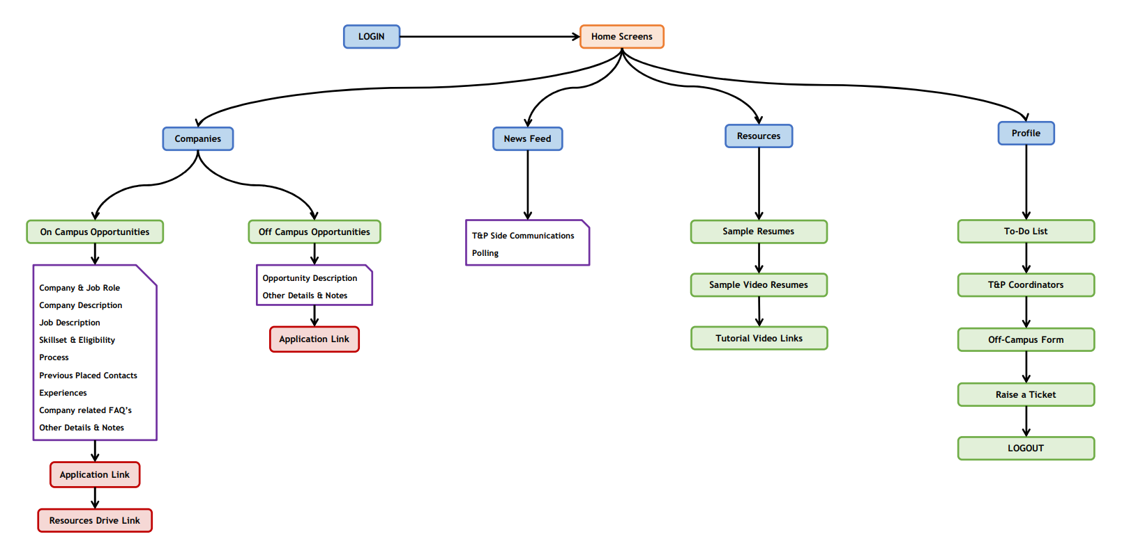

*Fig 2.3.1 - Workflow Diagram*

**2.4 Designs**

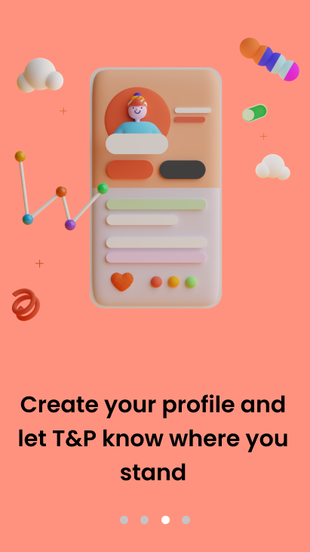

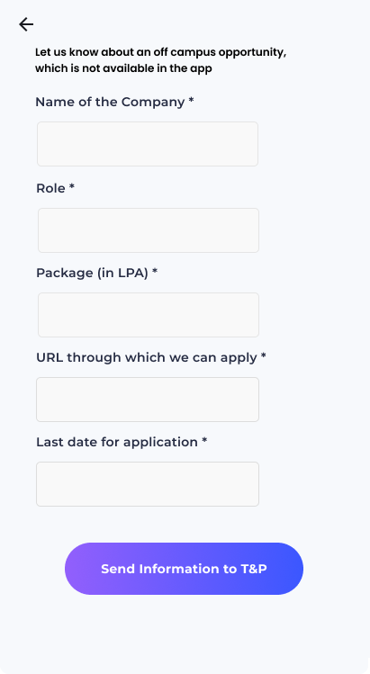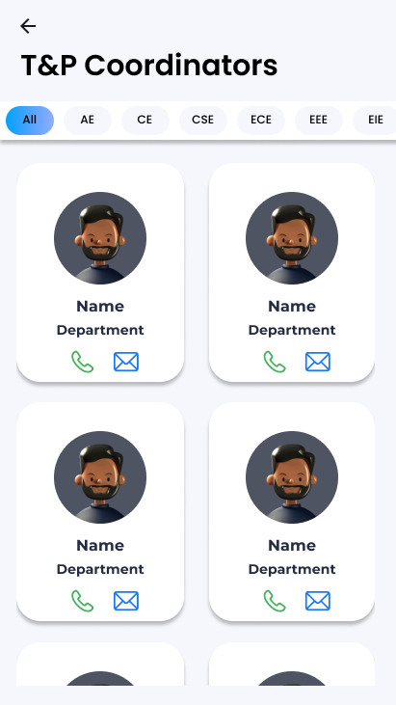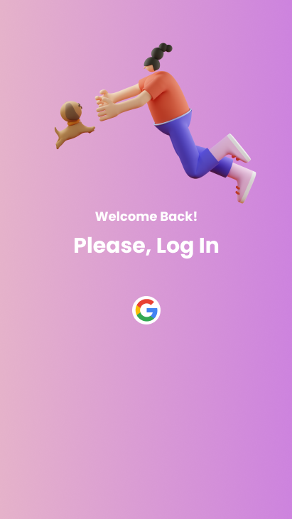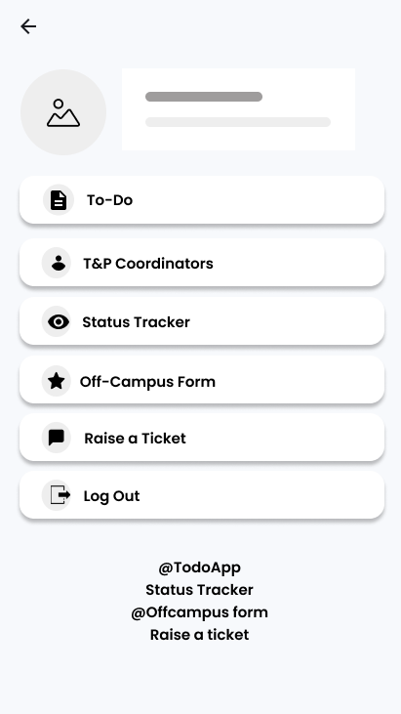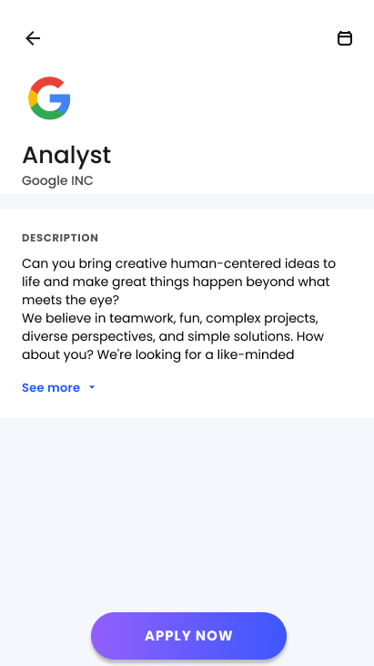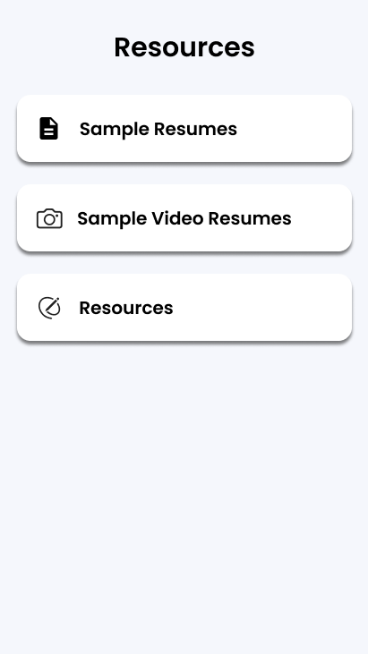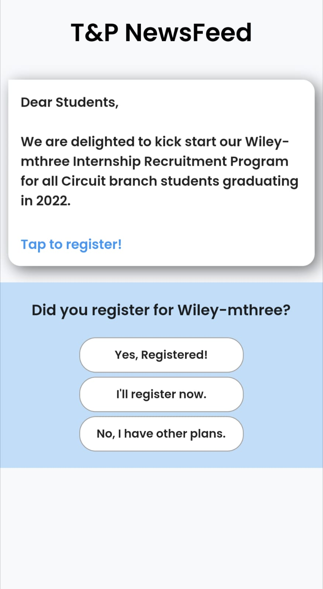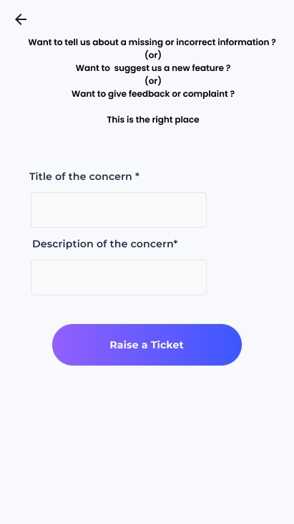

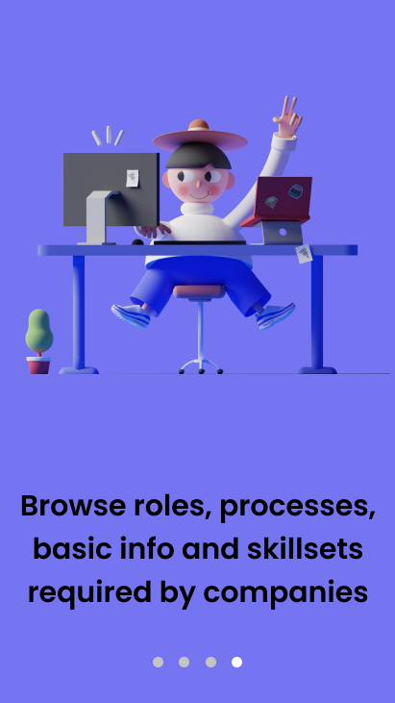

*Fig 2.4.1 – On-boarding Screens*

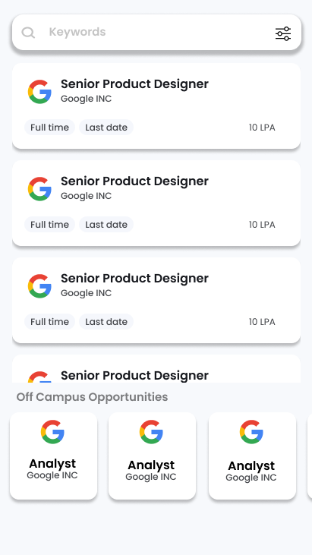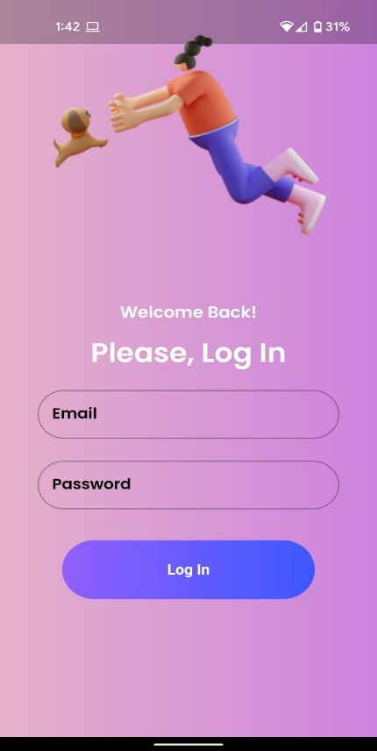



*Fig 2.4.2 – Login, Companies Tab, Off-Campus Opportunity Screen, Newsfeed and Resources Tabs*

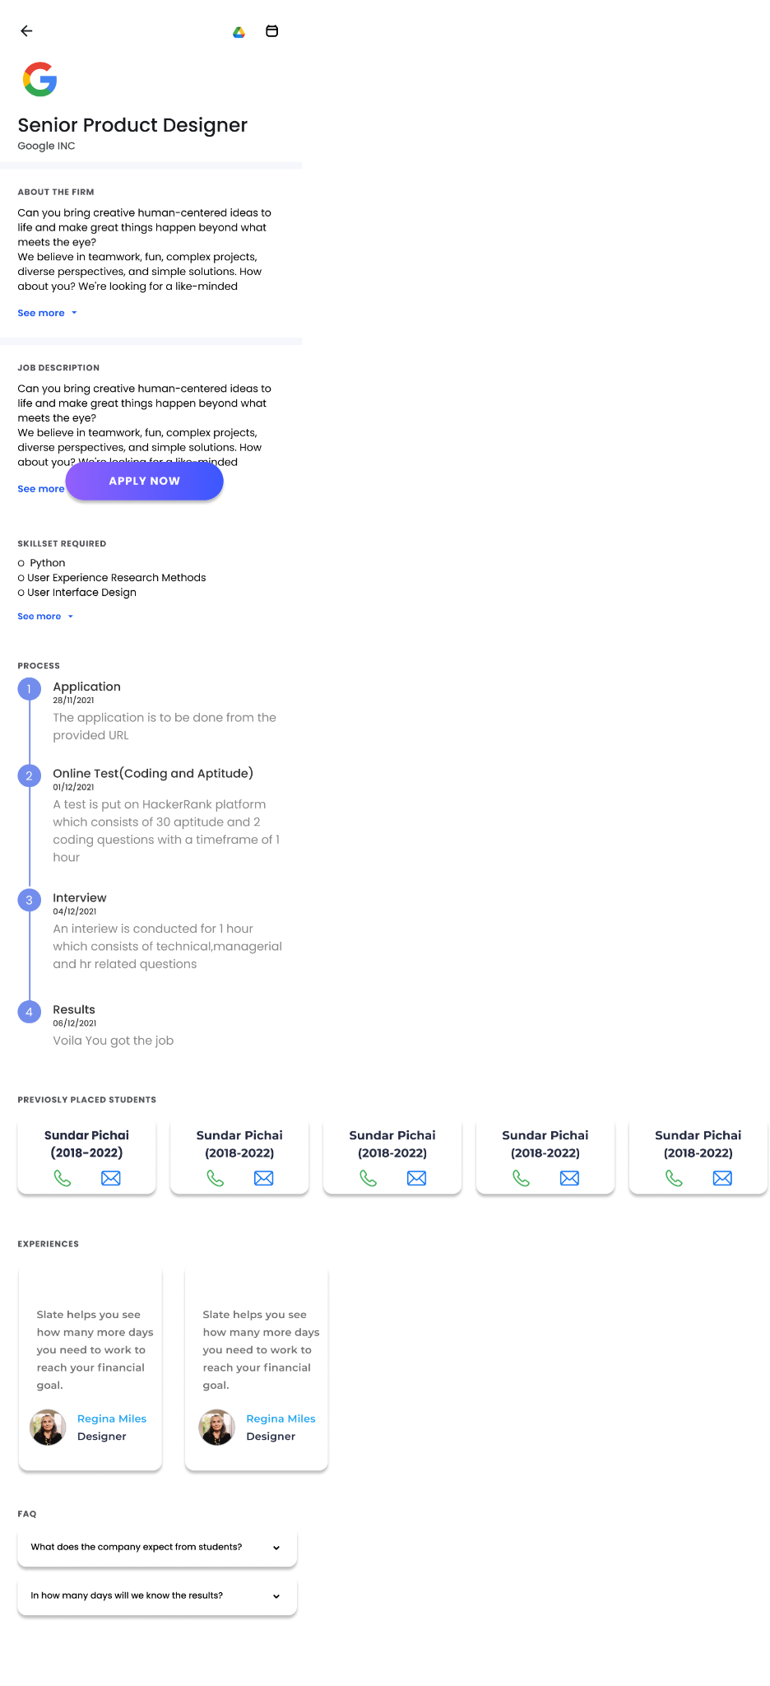



*Fig 2.4.3 – On-Campus*

*Opportunities Screen*

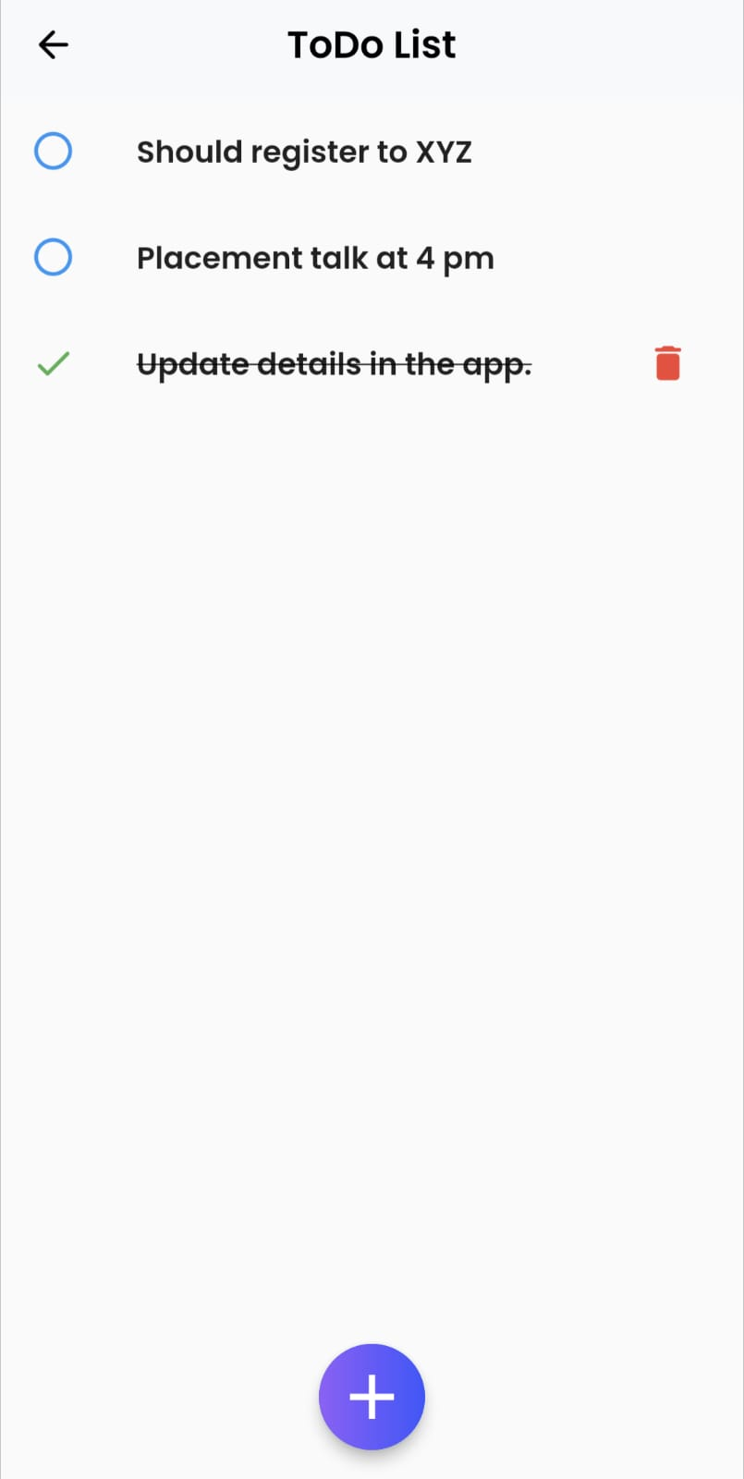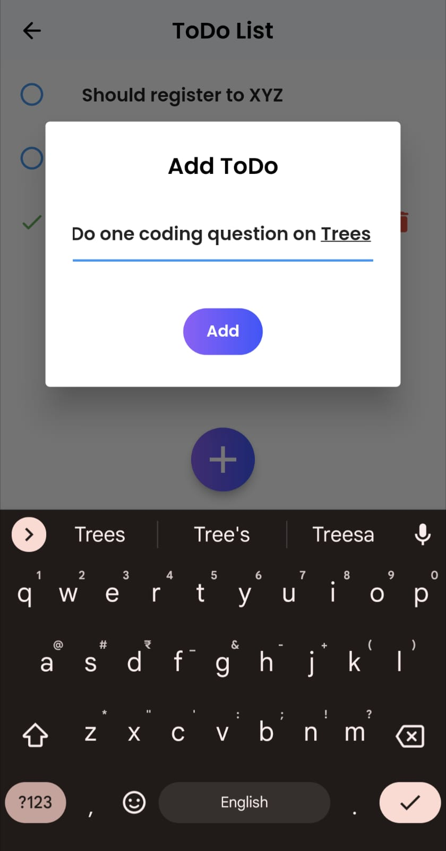

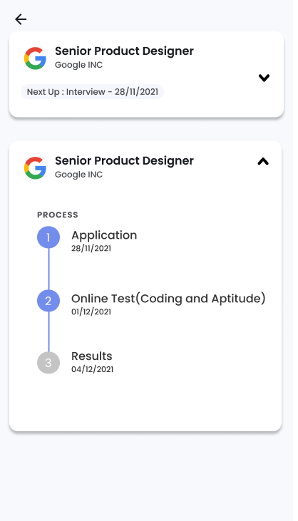

*Fig 2.4.4 – Profile and its constituent screens*



*Fig 2.4.5 – Off-Campus Opportunity and Raise Ticket Forms*

**CHAPTER – 3**

**CONCLUSION**

Placementor, both App and Website combinedly, would constructively help the college and students to have the process of placements being seamless and effective.

Based on the existing solutions, we considered their advantages and disadvantages and tried to integrate all the positive points while also trying to reduce the negative points in them to create a new solution for our college. The UI/UX has been built in such a manner that the user would get most of his/her placement related needs at his/her fingertips without confusion. All the information and functionalities have been embedded into the application (Both App and Website) in an easily understandable and usable manner.

It would reduce the work needed by placements team at the same time giving the maximum information to the student so that they can reach their goals. A complete two-way bridge of communication will be built between the college and students to ensure maximum efficiency from both of them.

**CHAPTER – 4**

**FUTURE SCOPE**

The solution can be improved and extended to make it more feasible. Some of the extensions are mentioned below.

**Integration with Eduprime**

The application can be directly integrated with Eduprime, our college’s one stop for all the information of a student and share data in both directions which would benefit the application as well as college.

**Providing the same services in other colleges**

The same application can be customized according to needs of other colleges and can be supplied to them.

**Direct Integration with companies**

Companies can be directly contacted and can be asked to give their placements via the mobile app removing the burden of placements team of colleges.

**Prediction of Future Drives**

Future drives along with their tentative deadlines could be predicted and shown to students so that they can prepare well in advance.

**Overview of placements to college and public**

Providing a complete statistical view of placements in the form of numbers and visualizations to T&P department, Management and Public.

**CHAPTER - 5**

**REFERENCES**

* Flutter Documentation

<https://www.flutter.dev/docs>

* Dart Documentation

<https://dart.dev/guides>

* Package Repository for Dart and Flutter

<https://www.pub.dev>/

* Google Firebase Documentation

<https://www.firebase.google.com/docs>

* Android & Android Studio Documentation

<https://www.developer.android.com/docs>